魅力ある大学院教育イニシアティブ「先端科学技術の芽を生み出す女性研究者育成」プログラム
（継続プログラム）

「国内学会・研究集会」参加報告書

２００８年12月19日
専攻・講座名
学年 博士後期課程 特別研究学生
氏名 Liu Tingting

On Dec. 3, we arrived Hokkaido, began our 2 days conference and 2 days study in this place. It was the first time that I came here, and Hokkaido was a beautiful city different from Nara.
On Dec. 4, we woke up early and went to Hokkaido Information University take part in the 45th winter conference of the remote sensing society of Japan. I listened Professor Diago’s presentation of “application of multiple factor analysis to AVIRIS data”. In his research, a multiple factor method was used to AVIRIS image data. Then, in poster room, I was interested in Haruki Oshio’s research about land cover classifications, because my segmentation research was similar with his. In his research, by using summer and winter MSS data, vegetation covers were identified and got a good result.
On Dec. 5, I presented about my research “remote sensing image retrieval based on semantic mining”. In my research, a multi-level image representation model was developed and used to mine semantic feature hidden in the original remote sensing image. This model was consisted of three levels: region level, region feature level and semantic level. The first two levels aimed at represent image content by using region feature. Semantic level aimed at extracting hidden semantic feature. At last, positive part and negative part method was used to improve the retrieval precision. Experiment showed that this method can well improve the accuracy of the retrieval result. After I finished, chairman asked me two questions about my research. Second question looked like more than an advice that TM image was big and made time consuming very large. So, I will add this advice into my future research. Following picture is the photo of me talking about my research.
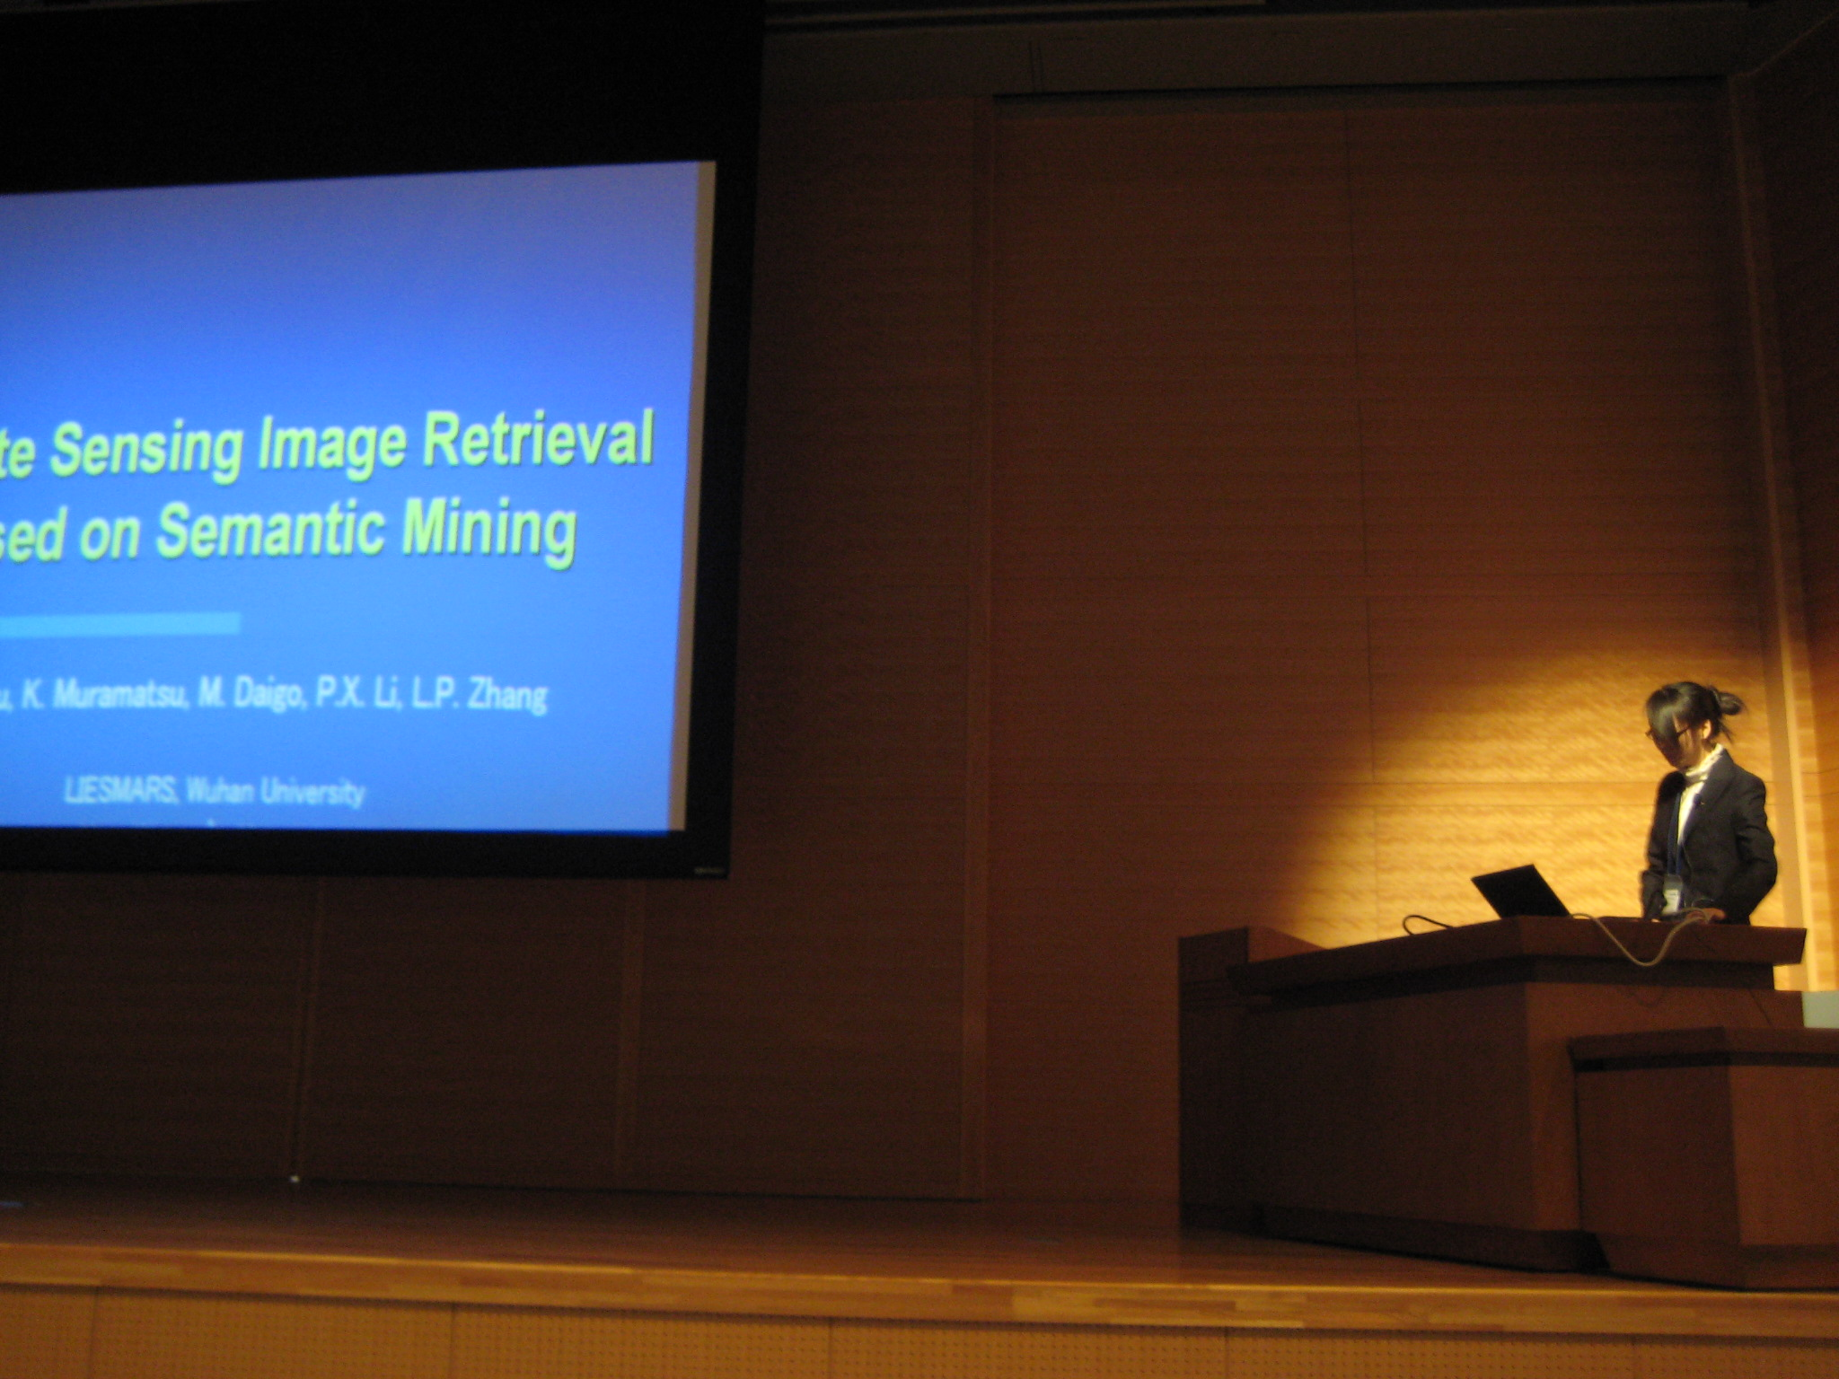
On Dec. 6, teachers took us to go to Nopporo forest, Utonai and Tomakomai snsyu rin. In my research, image was classified into different classes. After finished classification, the classification result had better to compare with true ground cover data in order to make sure the result whether correct. By checking true ground cover class, I found that some results of my research were good and other was not good. So next step, I will improve my algorithm.
