魅力ある大学院教育イニシアティブ「先端科学技術の芽を生み出す女性研究者育成」プログラム
（継続プログラム）

「国内学会・研究集会」参加報告書

２００８年12月22日
専攻・講座名 複合現象科学専攻
学年 博士後期過程 １回生
氏名 Thanyapraneedkul Juthasinee

I joined the 45th autumn conference of Remote sensing Society of Japan, 2008 in Sapporo at Hokkaido Information University during 3-7 Dec 2008. I had get some useful advises from expertise researchers in order to achieve my research activities goal. Moreover, after this RSSJ conference I had a chance to visit CO2 flux tower that is useful and can utilize for my research topic. Details of activities are shown below.
On 3 Dec, I departed form Kansai airport to Shitose airport and check in to hotel in Sapporo.
On 4 Dec, First day of conference. I listened to Daigo sensei presentation in land session about Application of multiple factor analysis to AVIRIS data. In afternoon at poster session room I listen to Soyama san presented her poster about Land cover classification of Uganda using GLI 250m mosaic data. And I am interested in Ono san poster about development of vegetation index using radiant spectra normalized by their arithmetic mean (VI), she doing research in shadow index (SI) that related and can apply this algorithm with my research in NPP estimation. Then after that I attended the special session the presentation that related my research is Inoue san presentation that about scientific research working group for problematic ecosystems remote sensing. After today conference, we had a welcome party at the university cafeteria.
On 5 Dec, Second day in morning I listened Miss Liu Tingting’s oral presentation about remote sensing image retrieval based on semantic mining. In afternoon is my poster presentation Fig1, my poster had 2 persons came and asked some questions also we had some discussions. After poster session, I went to forest session room.
On 6 Dec, Teacher, my colleagues and me went to natural center in Sapporo and then Utonai Lake; ramsar site wetland for ground truth observation. Then in afternoon we went to Tomakomai flux research site that located around in latitude: 42 degree 44’ N and longitude: 141 degree 31’ E, the elevation is about 140m above sea level, area around 98 ha as show in Fig 2. Tomakomai flux research site is located in the Tomakomai National Forest managed by the Hokkaido Regional Office of the Forest Agency. Vegetation types are Japanese larch (Larix kaempferi), Birch (Betula ermanii and Betula platyphylla), Japanese elm (Ulmus japonica) and Spruce (Picea jezoensis). Researching in Tomakomai flux research site are about carbon circulation in a northern larch forest. Information on the site and the measurement methods of eddy fluxes and meteorological elements is provided here. This data will be very useful for my future research on improvement of NPP calculation by using flux tower data site.
On 7 Dec, I departed form Shitose airport and then back to Nara.
I would like to thanks Nara Women’s University for supporting me to have a good chance for my research activity like this in Hokkaido the beautiful land.

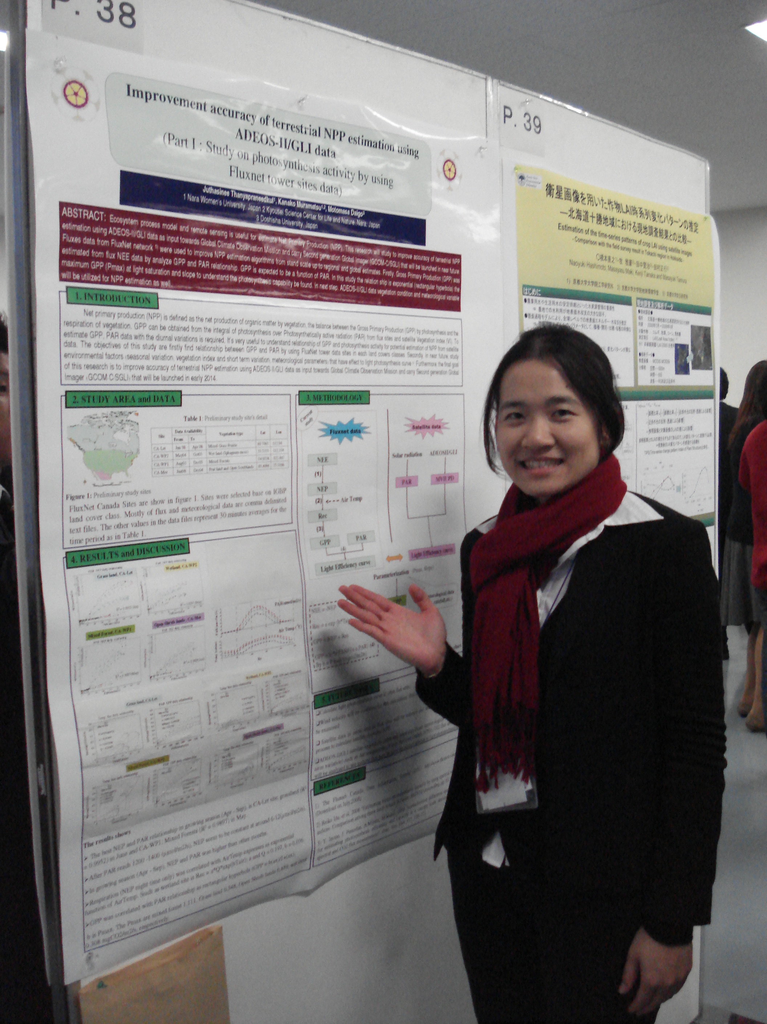

Figure 1 my poster

Figure 2 Tomakomai flux research site

